Family Risk and Safety Assessment (FRaSA) Part 1: A Systemic Approach to Risk Assessment and Safety Planning.
Craig Barlow & Marion Farmer

- Why Assess Risk?
Purposes of risk assessment include
- Promoting public safety
- Supporting routine interventions
- Targeting scarce resources (including time)
- Informing treatment plans
- Identifying the need for exceptional measures e.g. secure accommodation

- Common Assumptions
We can be anxious about or even impeded in our attempts to undertake risk assessments due to common assumption or beliefs e.g.:

- Child maltreatment is too rare to predict
- “Clinical Predictions” are particularly bad
- Social workers have no particular expertise in risk assessment
- Predictors of child maltreatment necessitate a deterministic view of behaviour

However,
- Family based violence and child abuse is all too common
- The accuracy of “clinical predictions” is reliably better than chance
- The scientific literature on family violence and child abuse and exploitation is large and growing
- Violence and child maltreatment is a choice or decision
- Focus on prevention, not prediction

- Definition of Risk
A risk is a hazard that is incompletely understood and therefore that can be forecast only with uncertainty.
It incorporates notions of nature, severity, frequency, imminence, and likelihood — not just probability of harm. Risk is context-specific Risk is never known, but estimated.

Definition of Assessment
Evaluation of an individual to assist in decision making. Decisions include treatment, civil commitment, supervision, sentencing etc. It is not simply providing a diagnosis or prognosis. It is not simply considering a set of test items or risk factors determined before the evaluation.
It IS Individualized inquiry.
- Summary:
Child Maltreatment Risk Assessment is the Evaluations of people to Characterize the risk that they will maltreat a child or children in the future in order to develop interventions to manage or reduce their risk of causing harm.

- Decision Theory
The proximal cause of harmful behaviour is a decision to act in a way that causes harm.
The decision is influenced by a host of biological, psychological, and social factors:
- neurological insult,
- hormonal
- abnormality
- psychosis
- personality disorder
- exposure to violent models
- attitudes that condone violence
Influences on Decision Making
- biological
- intelligence
- psychological Attitudes
- sexual deviation
- social exposure to antisocial models
- norms that condone crime or violence

- Systemic Risk Assessment
Systems Theory explains human behaviour as the intersection of the influences of multiple interrelated systems.
Systems Theory explains human behaviour as the intersection of the influences of multiple interrelated systems. According to this theory, all systems are interrelated parts constituting an ordered whole and each subsystem influences other parts of the whole. It is used to develop a holistic view of individuals within an environment and is best applied to situations where several systems inextricably connect and influence one another. For the purposes of Risk Assessment, contextual understandings of behaviour will lead to the most appropriate practice interventions.

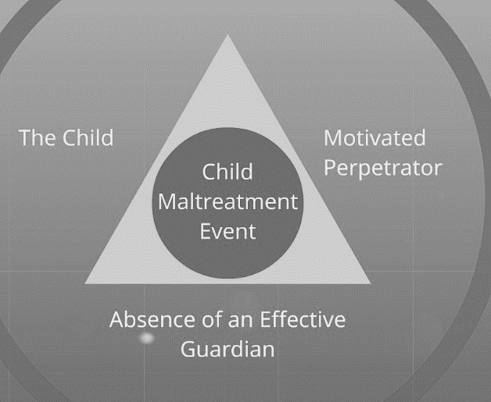
- Distal Factors
Preconditions of the individual e.g.
- genetic make-up,
- childhood experiences and development.
Long-term psychological mechanisms that may lead to harmful behaviour if the environmental situation is conducive.

- Proximal Factors
Factors in the environment that change the distal factors into actual abuse – effectively “trigger” the predispositions into actions.

- Goals of Risk Assessment
Risk assessments have, in the past, tended to emphasise prediction of harmful behaviour occurring e.g. the likelihood of someone becoming violent and to whom.
Risk Assessment and Safety Planning should be concerned with Prevention of harmful behaviour occurring. The Goals of risk assessment are therefore to:

- Prevent Harm
- Identify potentially useful intervention

But also:
- Enhance professional accountability
- Improve consistency of decisions
- Improve transparency of decisions
- Protect clients’ rights
- Protect professionals

- Two Basic Approaches to Risk Assessment
Discretionary: Designed to guide intervention this approach imposes no or limited structure
on the evaluation process and the decision-making process. It uses Information weighted and combined according to the evaluator’s judgement - AKA informal, intuitive, impressionistic.

Non-Discretionary: Designed to predict an outcome, this approach imposes rigid structure
on all of the evaluation process and on all of the decision-making process. Information is weighted and combined using fixed and explicit rules. AKA algorithmic, mechanical, formalistic
Examples:
- Child Abuse Potential Inventory(CAPI); Mullin
- Graded Care Profile; Srivastava
- Barrett Impulsivity Scale (BIS) II

- A Third way - Structured Professional Judgement (SPJ): Relies on professional guidelines, also known as aides mémoires or clinical practice parameters, the SPJ reflects current views of best practice and specifies important risk factors. It does not restrict the scope of the assessment nor does it specify methods for weighing or combining risk factors.

Examples:
- Adapted Systemic Investigation, Protection and Prosecution Strategy (SIPPS) for CSE; Barlow
- Risk of Sexual Violence Protocol ; Hart, Kropp & Laws
- HCR-20; Webster, Douglas, Eaves and Hart
- Short Term Assessment of Risk and Treatability (START); Webster, Martin, Nicholls and Middleton

The SPJ approach structures, but does not replace, clinical evaluations of risk across a broad range of populations and settings: Civil, forensic psychiatric or correctional, institutional or community based risk. It can be used individual practitioners or in teams. It enables practitioners to monitor or re-evaluate clinical and situational factors that may be relevant to risk of harm and guides risk management strategies.

- General Procedures
Use worksheets to assist evaluation and documentation and follows 5 steps:
- Gather assessment information
- Consider presence and relevance of risk factors
- Consider scenarios of violence
- Develop case management strategies
- Document summary judgements

- Planning The Assessment
- Identify Sources of Information
- Identify the Timeframe for the Assessment

Other issues to keep in mind:
- Open mindedness
- Impact or personal values
- Roles of fathers and other adult males in the household

- Assessment Principles
- Use multiple methods
- Use multiple sources
- Consider multiple domains
- Consider both static and dynamic aspects
- Update information
- Document information
- Evaluate adequacy of information

- Resilience
Family resilience is the successful coping of family members under adversity that enables them to flourish with warmth, support, and cohesion. Key factors include: positive outlook, spirituality, family member accord, flexibility, family communication, financial management, family time, shared recreation, routines and rituals, and support networks.

- Vulnerability
The extent to which a child is vulnerable is governed by Innate characteristics such as disability, communication difficulties, factors imposed by their family circle or wider community that may challenge healthy development for example, childhood trauma/abuse, poverty.

- Adversity
The experience of life events and circumstances that pose a threat to or challenge healthy development, for example: Serious illness, domestic violence.

- Protective Environment
Factors in the child`s environment acting as buffers to the negative effects of adverse experience, for example: Good school experience, availability of a supportive adult.

